Skin impression modeling across different skin types under different scenes
Beijia Qin,¹ Yuechen Zhu,¹ and Ming Ronnier Luo^{2,*}
¹State Key Laboratory of Extreme Optical Instrumentation, Zhejiang University, Hangzhou, CHINA
*m.r.luo@zju.edu.cn

Abstract:
This paper presents a comprehensive study investigating how facial skin colors influence various impressions across different ethnicities and under different scenes. The dataset consists of 700 images featuring 20 models under 35 distinct conditions: 21 laboratory settings (covering 7 correlated color temperatures (CCT) at 3 illuminance levels) and 14 real-scene environments. The models represent 4 ethnic groups and both genders. They were selected to cover a full range of skin lightness levels. Each model was rendered into 32 chromatic variations.
A psychophysical experiment was conducted with 20 Chinese observers, who rated the images based on 10 impressions: Preference, Attractiveness, Feminine, Cooperative, Youth, Healthy, Fidelity, Harmony, Fair, and Ruddy. In total, 3.5 million estimations were made. The results were used to establish a 50% acceptability ellipse model for each impression scale across the 35 conditions. The center of each ellipse represents the most positive impression. The effects of these skin colors on model ethnicities, impression scales, and scene are reported.
keywords: preferred skin colors, 50% acceptability ellipse, facial impression, scene capturing, ethnicity,
- Introduction

Facial skin color serves as a crucial cue of visual impression, conveying information about identity, emotion, health, and social interaction. Facial skin color has been extensive studied by a wide range of fields, such as cosmetic and skincare industry, the medical and clinical aesthetics, academic and social science researchers, the fashion and entertainment industries, illumination industry, etc. This work is very much focused on imaging industry, particularly in consumer photography in mobile phones, where accurate and preferred color reproduction is essential. People are not only concerned with color fidelity but also with color preference. In color reproduction, we often benchmark skin enhancement against memory colors, which are tones attached to familiar objects in our minds, and preferred colors, which are the aesthetically enhanced shades that consumers find most pleasing.

Early studies including Bartleson [1], Sanders [2], and Hunt et al. [3] were focused on Caucasian skin tones and found that the preferred skin tone was yellower and had higher chroma compared to natural skin color. Sanger et al. [4] expanded this research to include a multi-ethnic comparison and found that preferred chroma increased in the order of Caucasians, Mongolians, and Africans, while the hue angle remained consistent. Yano and Hashimoto’s study on Japanese women [5] revealed a preference for a reddish hue, which differed significantly from the hue preference observed in Caucasian women. As researches by Hashimoto et al. [5] revealed, compared with the actual complexion, the preferred complexion of Japanese women is slightly reddish and marginally higher in saturation. In comparison with the preferred complexion of Caucasian women, the latter shows no hue shift but has a saturation enhancement 3.5 times that of Japanese women. Yamamoto et al. [6] studied the ideal skin tones of women in China, Japan, and South Korea, and found that the descending ranking order of the lightness is China, Japan and South Korea, while the descending ranking order of hue angle and chroma is South Korea, Japan and China. However, Kuang et al. [7] and Fernandes et al. [8] argued that differences in preference across ethnic groups are minimal, emphasizing individual variation over cultural factors. Deng et al. [9] investigated the skin preference colors for the ideal male skin tones in China and Japan. Japanese observers preferred male skin color to be lower lightness, higher chroma, (deeper or suntanned skin) than Chinese observers. Park et al. [10] investigated the display skin color reproduction parameters for different ethnicities by analyzing psychophysical experiment results in the YC_{b}C_{r} color space. Zeng and Luo’s cross-ethnic experiment under D50 illumination [11] found that the preferred hue angle in the CIELAB color space centered around 49° for all ethnicities. Peng et al. [12] again found preferred skin colors for various ethnic groups are similar, with their chroma and hue values fluctuate at about 25 and 46º respectively. Cao et al. [13] investigated skin color preferences under different CCTs of lighting conditions and found that observers prefer light sources with higher CCT and the referred skin colors under these illuminants appear to have lower chroma than those of lower CCT illuminants. Luo et al. [14] introduced the Preference Memory Color (PMC) chart, which includes 4 memory color patches representing Caucasian, Asian, South Asian, and African skin tones. This chart is based on extensive research by Cao et al. [15] on mobile phone.

In addition to the above studies on average skin color in relation to preference or attractiveness, other impressions such as health, age, happiness, and upset have also been explored. Furthermore, color characteristics beyond average skin color have been found to influence facial perception. Lu et al. [16] investigated the impact of average skin color, local skin color, skin color variation, and facial color contrast on three key impressions: attractiveness, health, and age. They found that average skin color, together with color variation and contrast, strongly influences these facial impressions. Chinese observers were found to rely more on average skin color compared to Caucasian observers.

Wang et al. [17] explored how skin color affects 23 facial impressions using Chinese and Caucasian male and female images rated by 24 Chinese observers. Through factor analysis, they found that only five impressions, attractive, healthy, youthful, feminine, and cooperative—were sufficient to characterize facial perception. Liu et al. [18] extended this work by studying how skin color influences these five impressions and examining the color relationships among them. These findings are also incorporated into the present study. He et al. [18] studied the cross-cultural comparison on six terms, healthiness, preferences, brightness, whiteness, transparency and skin tones. They found skin colors that shift toward reddish and yellowish skin colors produced positive impressions (more attractive, healthier) for Asian and Caucasian observers, respectively.

Reviews have shown that, there exist qualitative rather than merely quantitative differences in the processing of familiar and unfamiliar faces, as familiar faces rely on abstract, view-invariant structural representations, while unfamiliar faces depend on concrete, view-dependent pictorial representations [19], and the familiarization of unfamiliar faces is a gradual transformative process of coding forms [20]. Studies have also shown that for familiar faces the serial dependence of attractiveness ratings is lower [21] and the detection of anger is easier [22] significantly than unfamiliar ones. The above have shown that familiarity between the model and the observer can influence performance in tasks including impression rating. However, in these experiments, the variable was facial morphological characteristics rather than average skin color. Nevertheless, researches by Fink [23] and Brebner [24] have demonstrated that effect of skin color can exist independently of facial geometry. Therefore, there is a reasonable hypothesis that the familiarity between the model and the observers might influence the relationship between facial impressions and skin colors. More specifically, the impression centers of familiar faces might be more robust against variable conditions.
From the above survey, we can find that the relationship between facial impression and models’ skin colors is based on a series of factors, including impression, scene, gender and ethnicity. The present research is intended to perform a comprehensive investigation by simultaneously capturing the facial skin colors of models from different ethnicities across representative photographic scene conditions. The goals of the present study are fourfold:
- To examine the preferred skin colors of four ethnicities under different scene conditions;
- To understand the impact of skin colors on 10 distinct impressions across the four ethnicities;
- To compare the preferred skin colors identified here with those reported in earlier studies; and
- To reveal the preferred skin colors between the stranger and acquaintance groups observers.

- Experiment Design

2.1 Dataset collecting
Twenty models (10 males and 10 females) participated in the experiment, spanning across the six Fitzpatrick skin types [25]: Very Light, Light, Medium, Tan, Brown, and Dark. A Konica Minolta® CM-700d spectrophotometer was used to measure skin color, with results reported in CIELAB coordinates under D65/10º conditions. Skin measurements were taken at five locations: forehead, left cheek, right cheek, left neck, and right neck. The mean values from these locations were used to represent each model.
The selected models cover a wide range of skin tones, as shown in Table 1, for which 10 grades are listed covering the full skin lightness range to the largest extent. Each model is labeled with a character ‘f’ for female and ‘m’ for male, followed by a digit from 1 to 10 corresponding to the lightness grade. For example, f01-f10 and m01-m10 represent the 10 female and 10 male models, respectively. The table outlines the model selection, i.e. Grades 01 to 03 are for Caucasian Models, Grades 04 to 06 for Asians, Grades 07 to 08 for South Asians, and Grades 09 to 10 for Africans. Notably, due to significant overlap in skin lightness (ranging from 65 to 70) between Caucasians and Asians (e.g., the L* values for f04 and m03 are 69.68 and 65.07, respectively), Grades 03 and 04 have the same L* range but for Caucasian and Asian ethnicities respectively. Note the 20 models were chosen from a group of 50 to give a good coverage in lightness of skin tones.

Table 1. The lightness levels used for model selection.
Lightness grade | Models | L*_{min} | L*_{max}
01 (Caucasian) | f01/m01 | 70 | 75
02 (Caucasian) | f02/m02 | 68 | 70
03 (Caucasian) | f03/m03 | 65 | 68
04 (Asian) | f04/m04 | 65 | 68
05 (Asian) | f05/m05 | 60 | 65
06 (Asian) | f06/m06 | 55 | 60
07 (South Asian) | f07/m07 | 50 | 55
08 (South Asian) | f08/m08 | 40 | 50
09 (African) | f09/m09 | 30 | 40
10 (African) | f10/m10 | 25 | 30

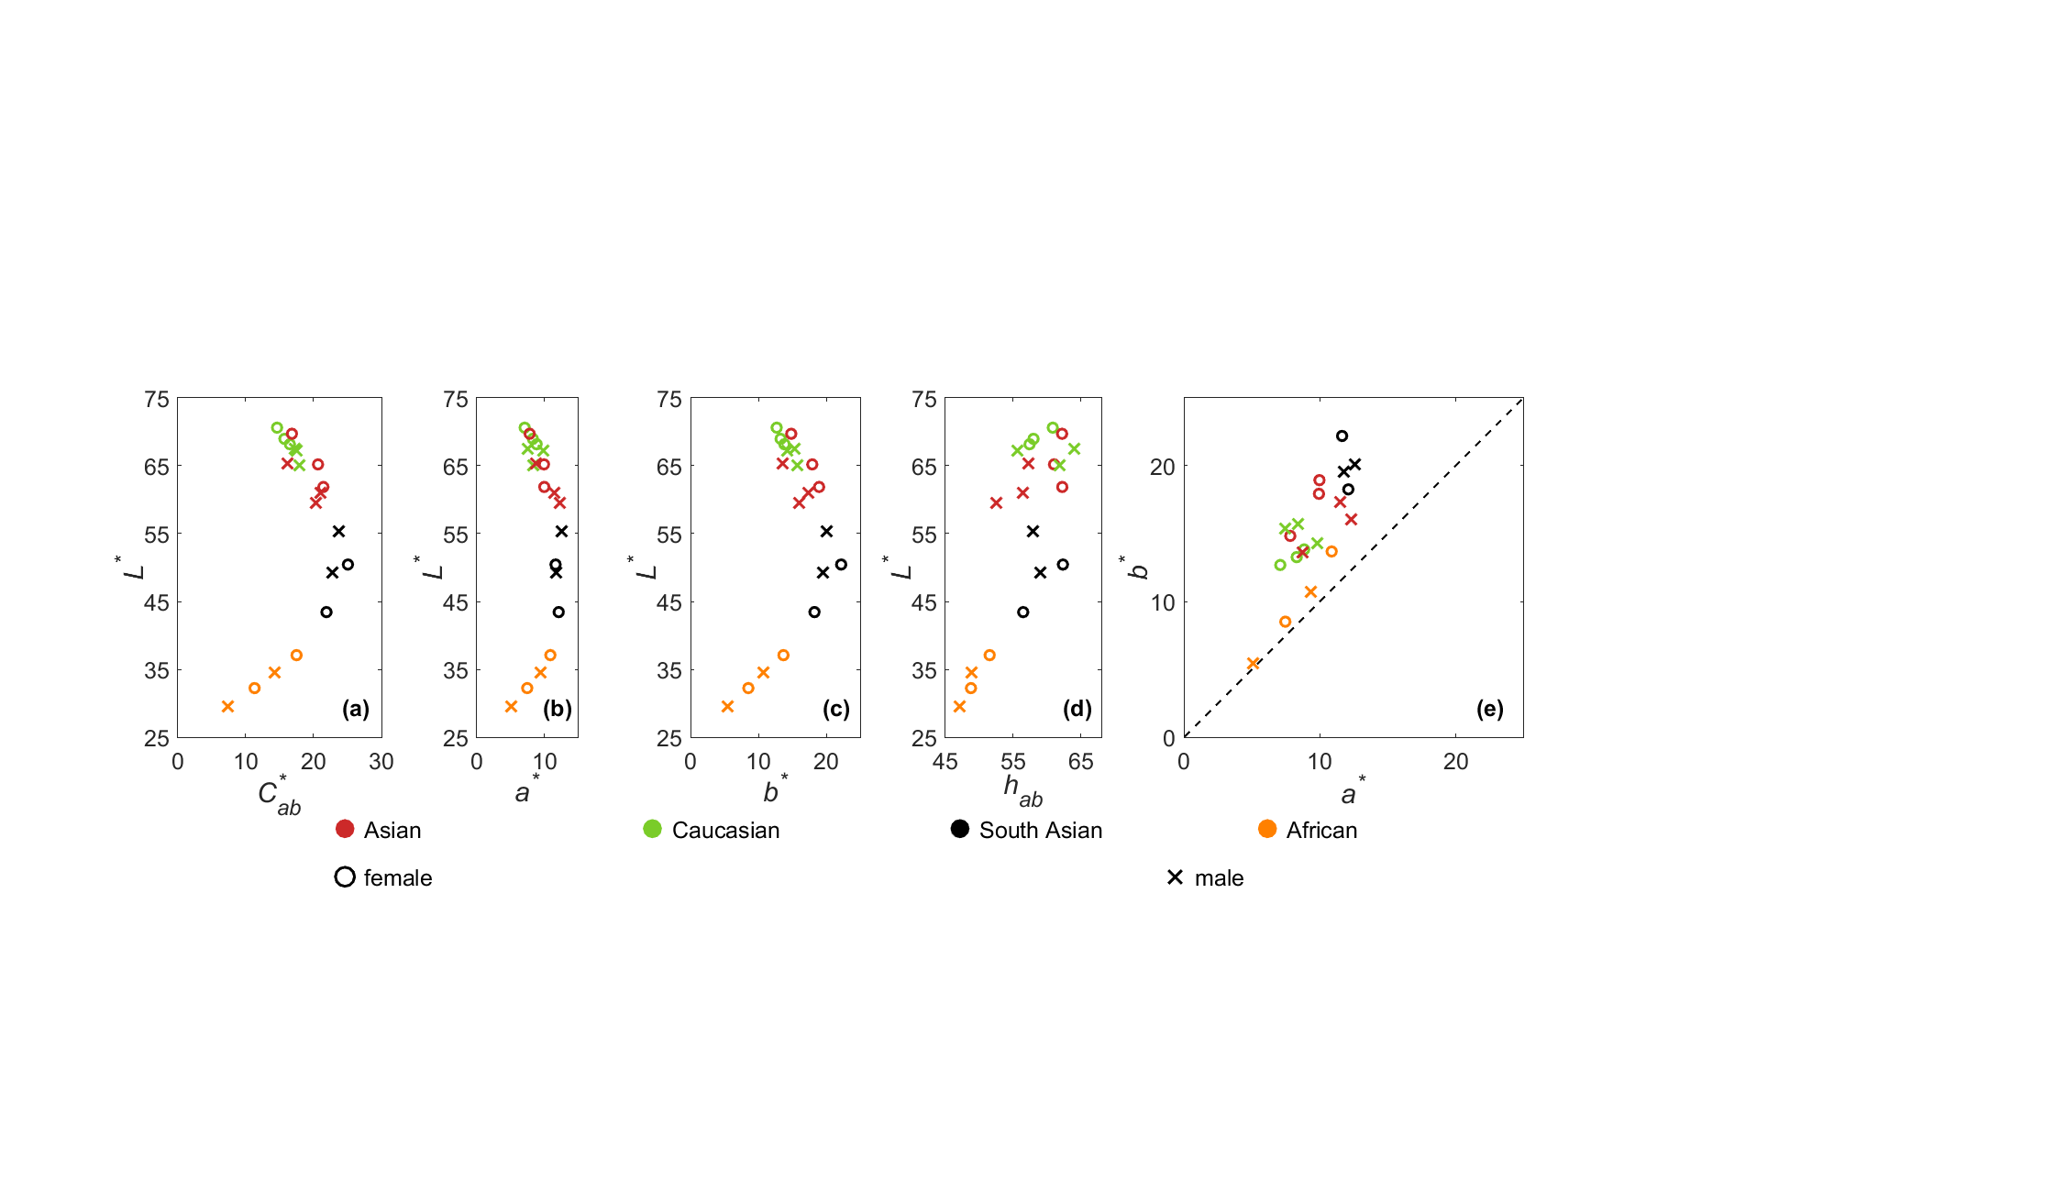
Figure 1. Plots of the measured skin color of the20 models in (a) L*C*_{ab}, (b) L*a*, (c) L*b*, (d) L*h_{ab,} and (e) a*b* planes respectively.
Figure 1 shows the skin color distribution of 20 models across different ethnicities. It can be seen that South Asian models have the highest chroma values. Female models generally exhibit lighter skin tones than males, except for South Asians. For African models, darker skin tones are associated with lower chroma values, while for Caucasians, lighter skin tones correspond to lower chroma values. To describe color distribution on a two-dimensional scale [26], African skin tones follow the vividness-blackness scale, while Caucasian and Asian skin tones align with the depth-whiteness scale, described as pale-deep. In Figure 1(d), it can be observed that all skin tones fall within the 47° to 64° hue angle range, with an average of 57°, which is above the 45° hue degree line. Note that in this article, when plotting data in a*b* plane, a 45º line is plotted to indicate the skin color to be reddish or yellowish.
Each model’s image was captured under two types of environmental conditions: in-lab and real-scene. For in-lab condition, images were captured in a studio with precisely controlled lightings, which is illuminated by 6 LEDCube units with spectrum-tunable lighting provided by Thouslite® as shown in Figure 2. Each model’s image was taken under seven correlated color temperatures (CCTs): 3000, 4000, 5000, 6000, 6500, 7000, and 8000K, across three illuminance levels: 100, 500, and 1000 lux. The CCT, Lux and Duv were controlled within ±50, ±1% and ±0.004, respectively.

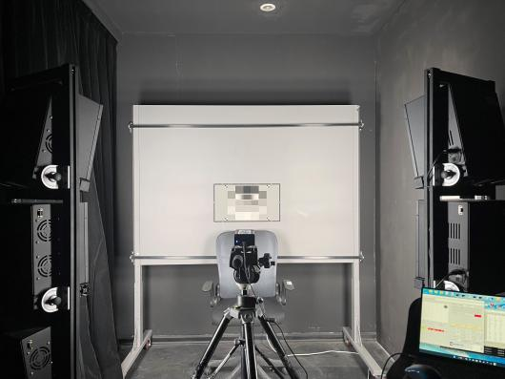
Figure 2. The studio lighting in in-lab environment
For each model, two images were captured for each scene, with inclusion and exclusion of PMC chart [14] respectively. The former was used to evaluate its white point to perform white balance and estimate the illuminance to serve as a reference when normalizing the skin color lightness for image rendering in the later stage. The latter was used in the real experiment.

Figure 3 presents example images of the 20 models captured under the D65 lighting under the in-lab condition. Each model number is given in each image.

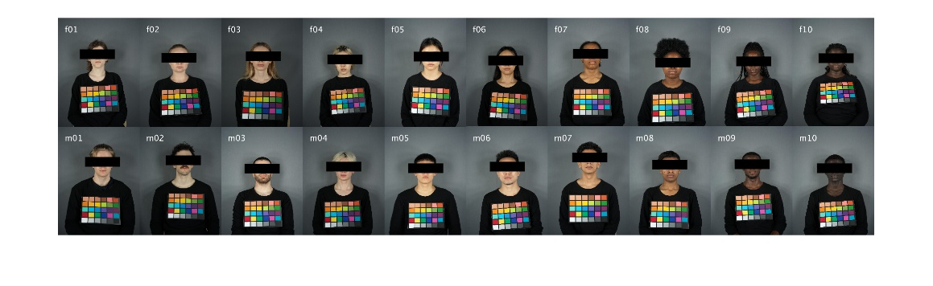
Figure 3. The images of the 20 models under the 6500K lighting of in-lab environment. They all wear the same black T-shirt.
Figure 4 shows the f05 model real-scene images. These include five indoor scenes (1: Basement mall, 2: Basement store, 4: School cafeteria, 5: School canteen, 6: School Starbucks) and seven outdoor scenes (3: Sunken plaza, 7: Grassland with front lighting, 8: Grassland with side lighting, 9: Grassland with back lighting, 10: Overcast scene, 11: Grassland with back lighting at sunset, 12: Grassland with side lighting at sunset), as well as two night scenes (13: Night scene, 14: Extreme night scene). Among the outdoor scenes, two are taken at sunset (11 and 12). Table 2 lists the name, the average CCT and illuminance levels for each scene, which were measured using a Konica-Minolta CL500A spectroradiometer in situ.

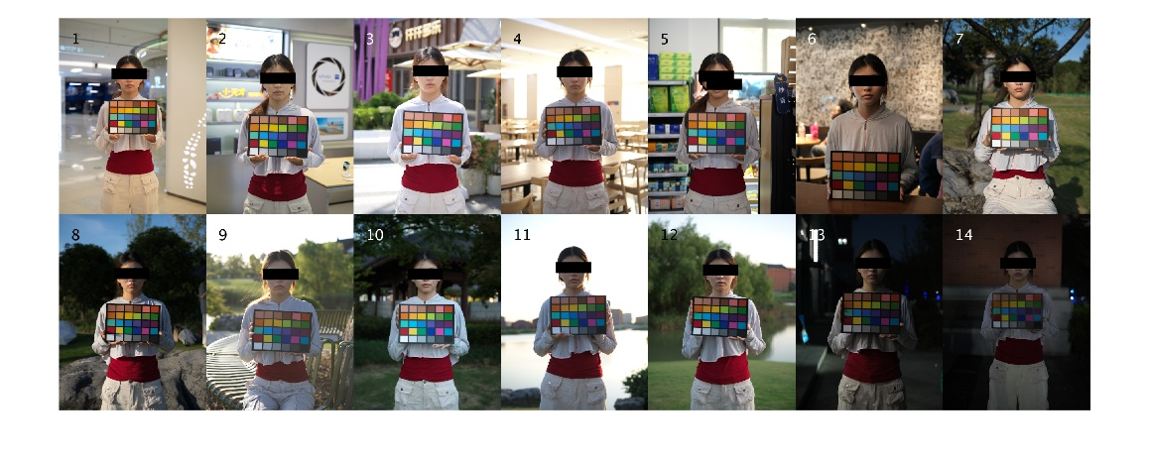
Figure 4. The images of the model f05 taken in 14 real scenes conditions,1: Basement mall, 2: Basement store, 3: Sunken plaza, 4: School cafeteria, 5: School canteen, 6: School Starbucks, 7: Grassland with front lighting, 8: Grassland with side lighting, 9: Grassland with back lighting, 10: Overcast scene, 11: Grassland with back lighting at sunset, 12: Grassland with side lighting at sunset, 13: Night scene, 14: Extreme night scene.

Table 2. The CCT and luminance for each scene.
Serial | Scene | CCT (K) | Luminance (cd/m²)
1 | Basement mall | 2816 | 116.80
2 | Basement store | 5335 | 102.21
3 | Sunken plaza | 5850 | 92.65
4 | School cafeteria | 5131 | 119.31
5 | School canteen | 4539 | 82.87
6 | School Starbuck | 3583 | 21.82
7 | Grassland with front lighting | 4705 | 49.69
8 | Grassland with side lighting | 5897 | 64.06
9 | Grassland with back lighting | 5629 | 116.77
10 | Overcast scene | 8982 | 34.28
11 | Grassland with back lighting at sunset | 6092 | 174.09
12 | Grassland with side lighting at sunset | 6471 | 91.63
13 | Night scene | 5545 | 12.78
14 | Extreme night scene | 5325 | 5.38

The images in this experiment were acquired under strictly controlled lighting conditions. The 20 models divided into 5 groups were first gathered at the campus and then traveled together to take shots in the 14 outdoor scenes and 21 in-lab lighting conditions. Overall, 700 images were taken (20 models, 35 images for each). The models come from 11 countries and they lived in 5 different cities in China. Images of the 14 real scenes were taken at 15 scenes from 2 to 8 p.m. of each shooting day, with all shooting days arranged within one week in July 2024.

2.2 Image processing
The images were used to assess visual impression. The workflow to produce these images is given in Figure 5.

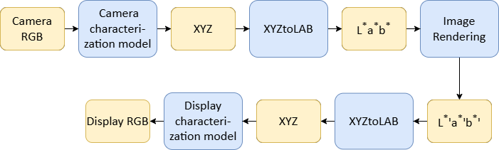
Figure 5. The workflow to prepare experimental images. The blue blocks are computation steps and yellow blocks are input and output data.

There are 5 steps of computation including the forward and reverse CIELAB model [27]. The other three steps are introduced below: camera and display characterization models and image rendering.

Camera characterization model
A Hasselblad X100C camera was used to capture all images under in-lab and real scene conditions. The images in RAWRGB format were transformed to XYZ via the camera characterization model, which is a second-order polynomial, incorporating 11 colorimetric terms developed by Hong and Luo [28]. An Xrite ColorChecker® Digital SG chart, which includes 96 colors, served as the color target. The camera’s RGB values were extracted as output data. Also, a Konica-Minolta® CS2000A spectrophotometer® was used to measure the spectral reflectance, which was then used to calculate the XYZ tristimulus values under D65/10° condition. The 30 colors in the PMC chart® [14] were used to validate the established model. The results showed a good performance to back predicted the 30 target colors with a mean of 1.92 CIEDE2000 [29] units. This step was aimed to ensure that the stimuli entering the processing pipeline is to the largest extent close to that viewed directly under the shooting condition.

Display Characterization
Ten smartphones were used in the experiment, and a Konica Minolta® CS2000A spectroradiometer was employed to measure screen colors to perform display characterization. A 9×9×9 three-dimensional lookup table (3DLUT) model [30] was created using 729 color patches, with the corresponding RGB and XYZ values. The 96 color patches from the Digital SG chart were used to test the model’s accuracy. The results showed an excellent performance of one model’s performance, i.e. 0.5 CIEDE2000 units and using the same model to predict the other mobiles result in a mean of 0.57 with a maximum of 0.68. This result is considered to be excellent in model accuracy and inter-mobile agreement. This step was aimed to ensure the stimuli the observer viewed is to the largest extent close to that recorded after all the previous processing steps.

Image Rendering

Each of the 700 images captured was then rendered to 33 images in CIELAB space to cover a reasonable color gamut for the psychophysical experiment. Figure 6 shows the increments Δa*Δb* of the 33 points uniformly distributed in a*b* plane surrounding the center (0,0). These points were generated, according to the experimental ellipses from Zeng and Luo [31].

For some studies, they were carried out under non D65 illuminant. Their color center was transformed to D65 via CAT16 [32], followed by the rendering under D65 illuminant.

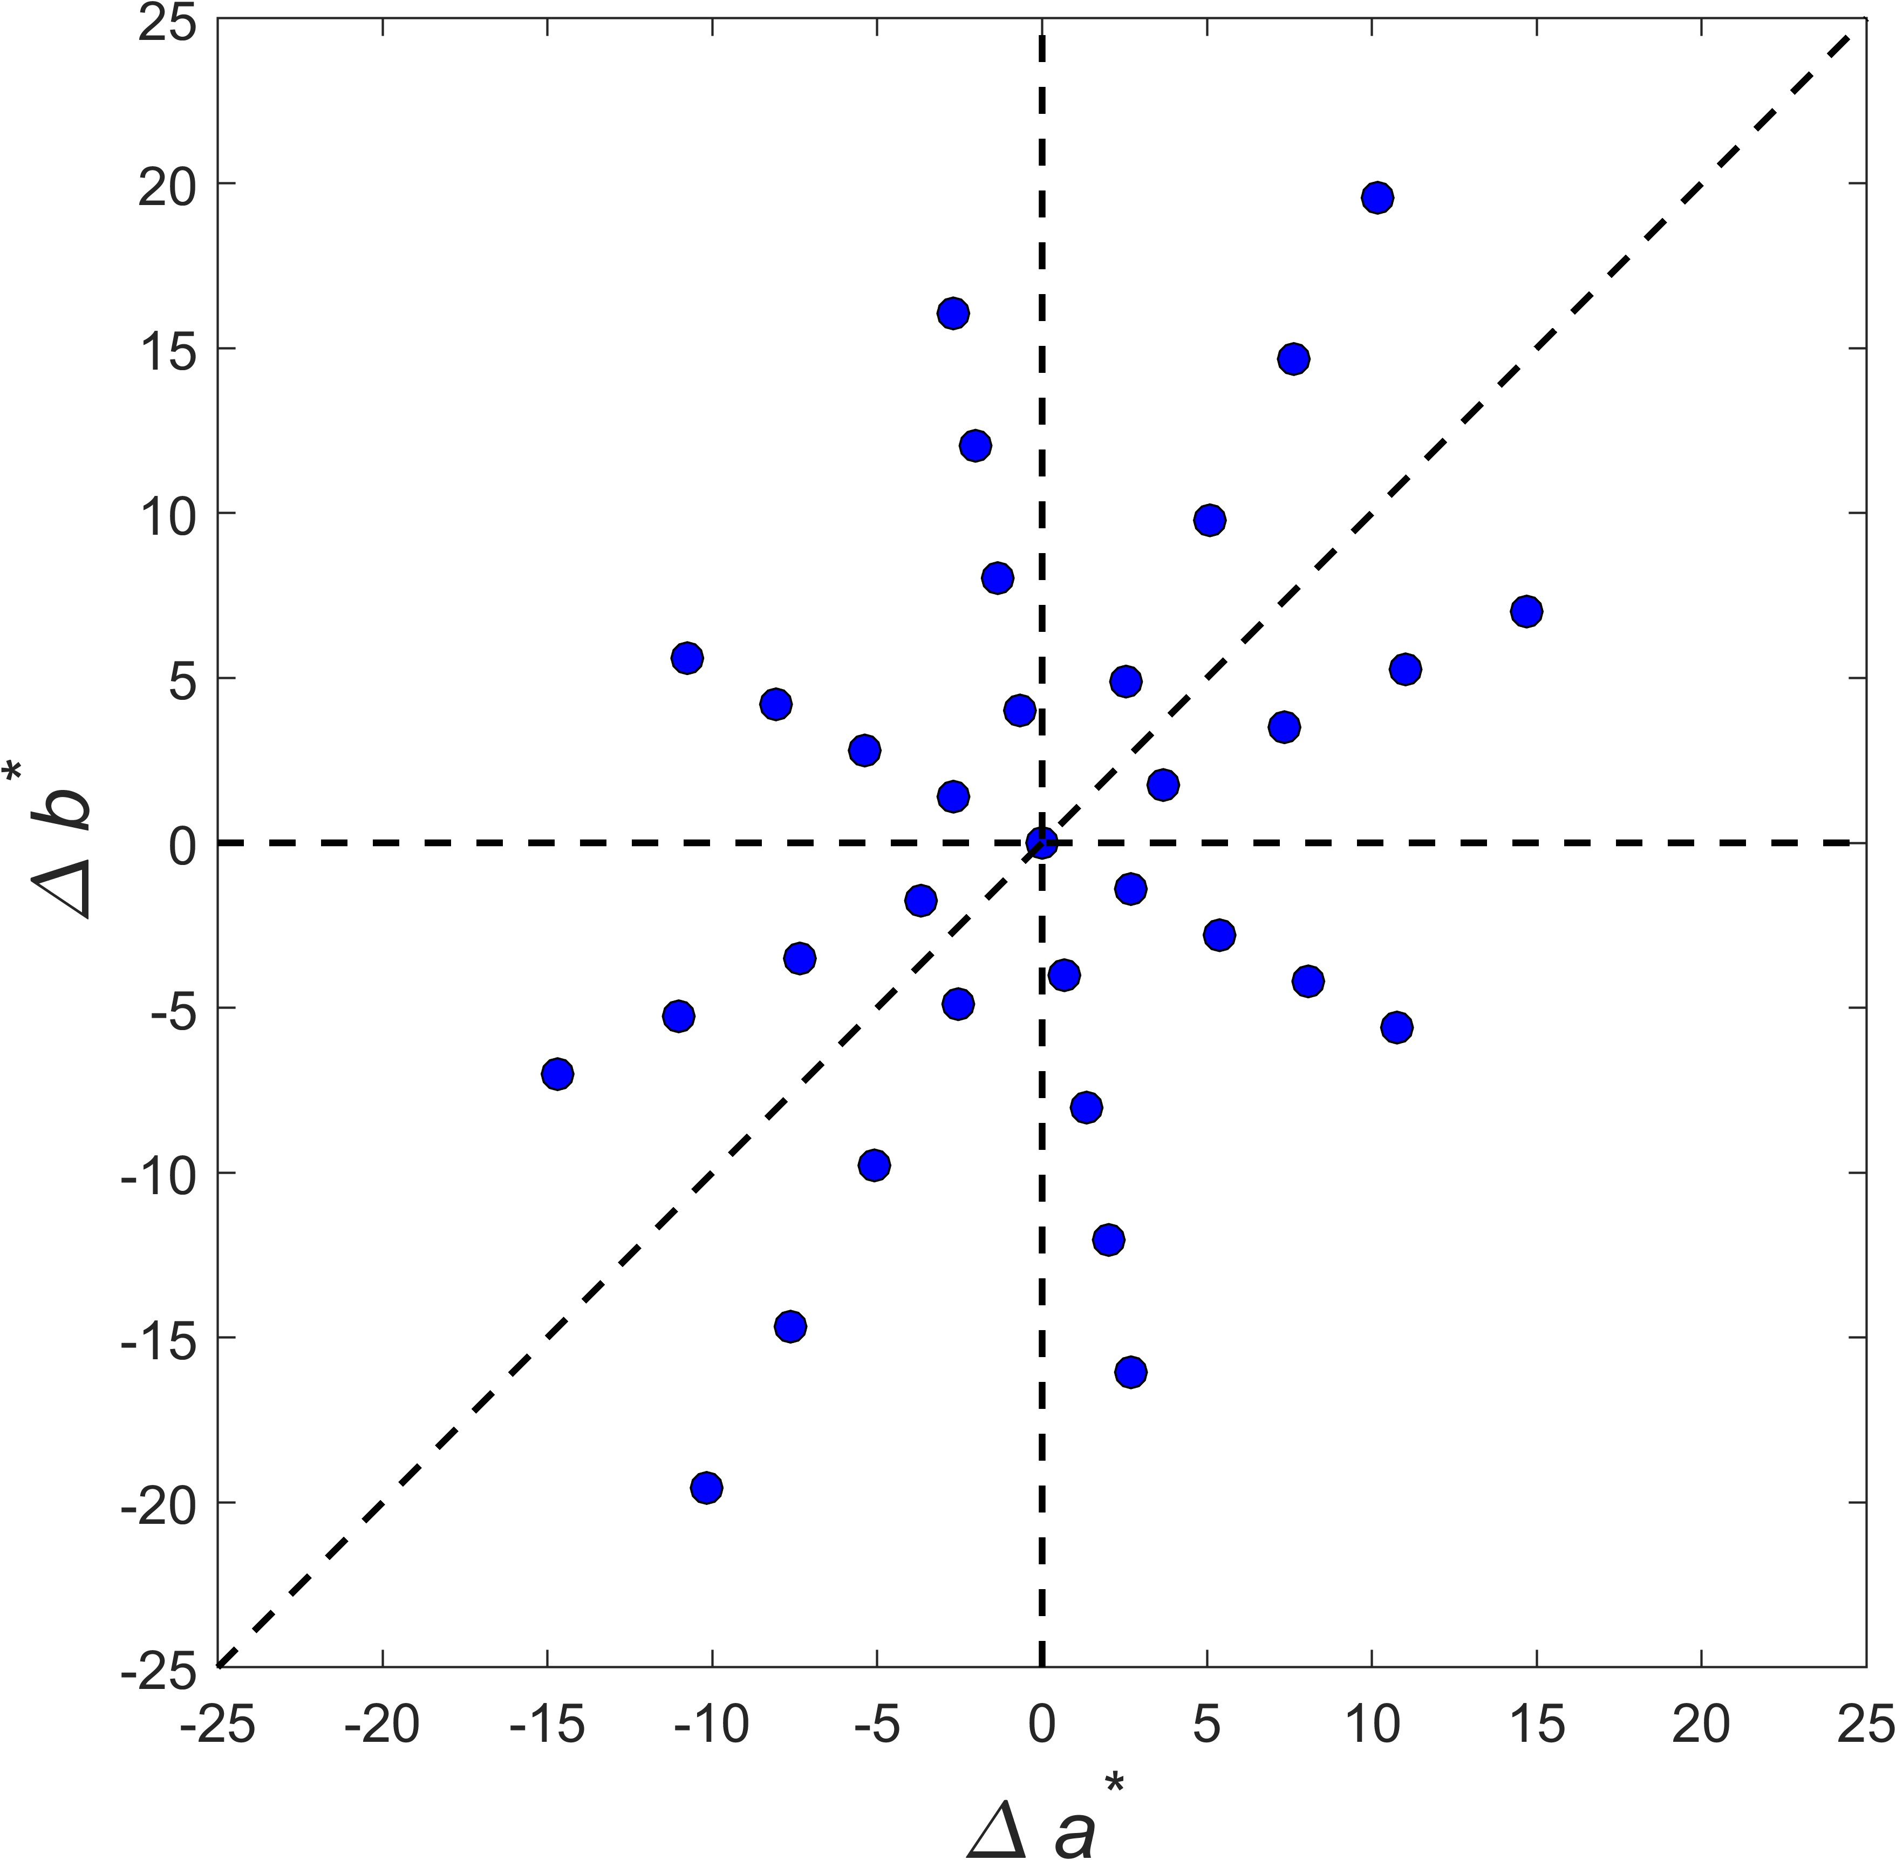
Figure 6. The rendered distribution of 32 rendering data plotted in a*b*plane under 6500K.

  - Experimental Procedures
The experiment was conducted in a darkened, windowless room. Figure 7 shows the experimental situation. The mobile display was positioned in a vertical plane covered by a black cloth and a chinrest was placed at a viewing distance of 40 cm away from the screen to ensure consistent observer positioning.

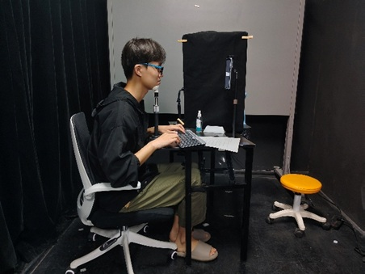
Figure 7. The experimental situation
A total of 20 Chinese observers participated in the visual assessment of each model. The mean age of the participants was 24, ranging from 20 to 27, with a male-to-female ratio of 6:4. The observers can also be divided into two groups: 15 strangers who did not know the models, and 5 individuals in the acquaintance group who personally knew the models. This was intended to investigate whether the observers’ decisions would be influenced by their familiarity with the models. Table 3 summarizes the number of visual assessments conducted during the experiment. In total, 3,470,600 judgments were made in this study. Each observer took part in 8 sessions, each 1 hour. The whole experiment took a period of 6 months to complete.

Table 3. A summary of the experimental information.

Ethnic group | Models | Original Images | Observers | Number of Impression scales | Reproductions | Total
Asian male & female | 6 | 35 | 15/5 | 9/10 | 37 | 1,437,450
Caucasian Female | 3 | 35 | 15/5 | 7/8 | 37 | 563,325
Caucasian Male | 3 | 35 | 15/5 | 6/7 | 37 | 485,625
South Asian Female | 2 | 35 | 15/5 | 5/6 | 37 | 271,950
South Asian Male | 2 | 35 | 15/5 | 4/5 | 37 | 220,150
African Female | 2 | 35 | 15/5 | 5/6 | 37 | 271,950
African Male | 2 | 35 | 15/5 | 4/5 | 37 | 220,150
Total | ‐ | ‐ | ‐ | ‐ | ‐ | 3,470,600

Note not all 10 impressions were assessed for all ethnic groups and gender. Observers did assessments to all 10 impressions for the trials in the Asian group. Later it was found that the scores were very similar between Preference and Attractiveness, so the latter was removed for the other ethnic groups. Additionally, most observers reported that the impression of Cooperative was not related to skin color. Likewise, Feminine was not used for assessing male models. As a result, after completing the experiments for Asian models, the impression scales of Attractiveness and Cooperative were discarded, and Feminine was removed for the assessment of male models. Furthermore, observers did not find Fair and Ruddy meaningful for South Asian and African models, so these scales were excluded for these two ethnic groups. Finally, since stranger group observers were unfamiliar with the models’ skin color, the Fidelity scale was removed for this group.

The evaluation was conducted using a six-categorical impression scale to assess each of the 10 impression scales for each image. Observers rated the skin color in each image on a scale from -3 to 3 (excluding 0, force choice), where -3, -2, and -1 represented strongly, moderately, and slightly negative, respectively, and 1, 2, and 3 represented slightly, moderately, and strongly positive, respectively.
When performing the experiment, observers navigated through the image sequence using the keyboard: the left arrow to go back to revise a score, while the right arrow key move to the next image. The serial number of the current image and the total number of images assessed were displayed in grey text on the interface. Figure 8 shows the experimental image on the display. In the experiment, there are 35 phases of scene conditions and these are randomly arranged for each observer together with the sequence of impressions. In each session, each observer did a 60-second adaptation at the beginning, as well as a 20-second adaptation period between phases.
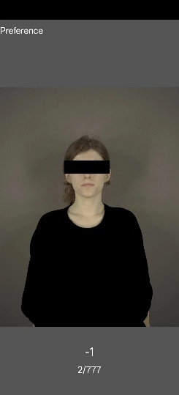
Figure 8. An experimental image evaluated
The 10 impression scales were based on Wang et al.’s study [33] and some suggested by professional photographers. Impressions were assessed by each observer following a random order. The observer did one impression scale for all the images of the model within one experimental session. The definitions of these impressions given below are introduced before the experiment. Different impressions were introduced before the experiment.
- Preference: Overall impression of the skin color in the image. Negative scores indicate that the skin color is considered unacceptable or disliked.
- Attractiveness: Assesses whether the skin tone appears attractive to the observer. A negative score reflects a perception of unattractiveness.
- Feminine: Evaluates the perceived femininity of the skin color. Negative scores indicate a more masculine appearance.
- Cooperative: Assesses whether the skin color gives an impression of friendliness and approachability. Lower scores suggest the opposite, i.e., unfriendly or unapproachable.
- Youthful: Evaluates whether the skin tone appears youthful. Negative scores imply an older or less vibrant appearance.
- Healthy: Assesses whether the skin color conveys a sense of health. Negative scores denote an unhealthy or sickly appearance.
- Fidelity (evaluated only by the acquaintance group): Assesses how accurately the skin color in the image reflects the real-life skin tone of the model. A high score indicates a natural, accurate representation of the model’s true skin color.
- Harmony with Environment: Evaluates the visual harmony between the skin color and the surrounding scene, considering elements such as lighting brightness, color temperature, and the semantic context of the real scene settings.
- Fair: Assesses the visual lightness and clarity of the skin tone. Higher scores represent brighter, fairer skin, while lower scores suggest dull or yellowish tones.
- Ruddy: Assesses the presence of a healthy red tint in the skin, indicating whether the complexion appears rosy or pale.
In summary, each model’s images were captured in 35 scene conditions, 21 in-lab light sources (3 illuminances × 7 color temperatures) and 14 real scenes. With 20 models in total, this resulted in 700 original images. Each original image was rendered into 33 renditions, and 10% of the images were repeatedly, yielding 37 images per set for perceptual evaluation. In total, a massive of 3,470,600 judgments were made in this study. The total experimental duration was approximately 3,000 hours, each observer did about 8 hours. All observers were confirmed to have normal color vision by passing the Ishihara vision test.

- Data Analysis

3.1 Observer Variations
The standardized residual sum of squares [34], was used to indicate the intra- and inter-observer variability by means of the mean, maximum, minimum of STRESS values. The intra-observer variation was calculated between the two sets of scores on the repeated images (10% of the entire dataset) and the inter-observer variation was computed between each subject’s scores and the mean scores. Table 4 shows the inter-observer and intra-observer variations.

Table 4. The inter-and intra-observer variations in STRESS unit.
 | Mean | Maximum | Minimum
Inter | 37 | 49 | 28
Intra | 17 | 23 | 13
The intra-variation was 17 STRESS units (approximate 17% variation), indicating high consistency for subjects. The inter-observer variation is higher than intra-observer variation as expected, yet the results here is comparable to our earlier experiments [11,12,13,15].
The individual and panel observer’s impression centers are calculated by Equation as the centroid of the cluster.
where n is the number of the positive rendering points (pre-selected points with a p value higher than 0.5), a_{i} b_{i} are the coordinates of these positive points on a*b* plane, and p_{i} is the impression percentage (ratio of observers who give positive impression scores) when calculating the overall impression center, or normalized impression score when calculating the individual preference center. Note all the skin colors in the subsequent data analysis was done under D65 by transforming the skin color coordinates under other illuminants to D65 via chromatic adaptation transformation (CAT16).
The Mean Color Difference from the Mean (MCDM) was used to indicate the inter-observer variation, i.e. the mean color difference between the overall impression center and individual preference centers. Figure 9 shows the inter-observer variation in MCDM units for each impression and each ethnicity.
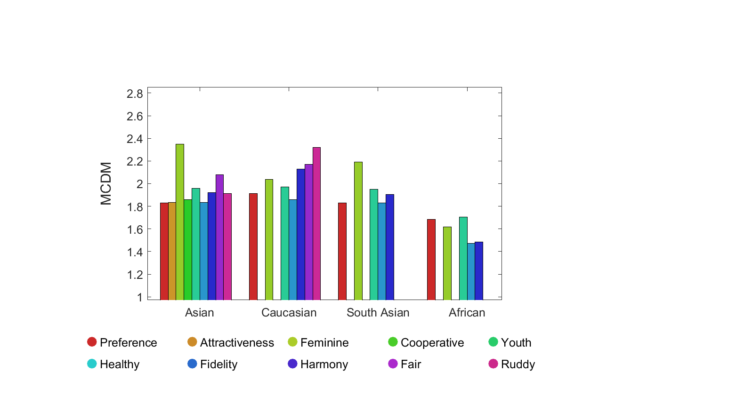
Figure 9. Observer variations in MCDM for different ethnicities and impression scales.
The minimum, maximum, and average values of the MCDM are 1.47, 2.35, and 1.93, respectively. The MCDM values for the Asian, Caucasian, and South Asian ethnic groups are comparable, while the MCDM for the African group is relatively low. This is because the African group’s lightness is lower, which narrows the skin color preference range, resulting in a smaller MCDM. The impression scale Ruddy has the highest MCDM, followed by Feminine and Fair. This is understandable, as these three scales are more abstract compared to the others. Overall, the average MCDM for all ethnic groups and impression scales was 1.83, with a range from 1.13 to 2.24.
.

3.2 Calculation of 50% impression tone ellipses
For each image, the ratios of positive scores from 20 observers were calculated to obtain the impression percentage P_{v}, from which the 50% acceptability ellipsoid is fitted using Equation :
where P_{p} is the percentage of the model prediction (i.e. the ratio of observers giving positive grade (>0)). The k₁, k₂, k₃ and α are the fitting parameters to be optimized. The a₀ and b₀ are the coordinates of the preferred or impression skin color on a*b* plane calculated by Equation . Those parameters are optimized to achieve a highest Pearson correlation coefficient (r) between the observer data (P_{v}) and the predicted data (P_{p}) in Equation . The mean r between the visual data and the model prediction from all impression scales is 0.97, indicating the robustness of the ellipse model.
- The parameters affecting the skin color impression
This section is intended to reveal the effect of different factors on skin colors such as model ethnicities, impression scales, scenes, observer familiarity with the models and facial lightness levels. This results in many comparisons between different conditions. All skin colors were computed using the white patch in the PMC chart present in images as reference white.

4.1 Comparing between the physical measurement and preferred skin colors
For skin color research, it is typically to find the direction of color shift to achieve preferred skin color. It is also frequent to compare colorimetrically measured colors with and preferred colors, as shown in Figure 10 for the 20 models in CIELAB a*b* and L*C_{ab}* planes respectively.

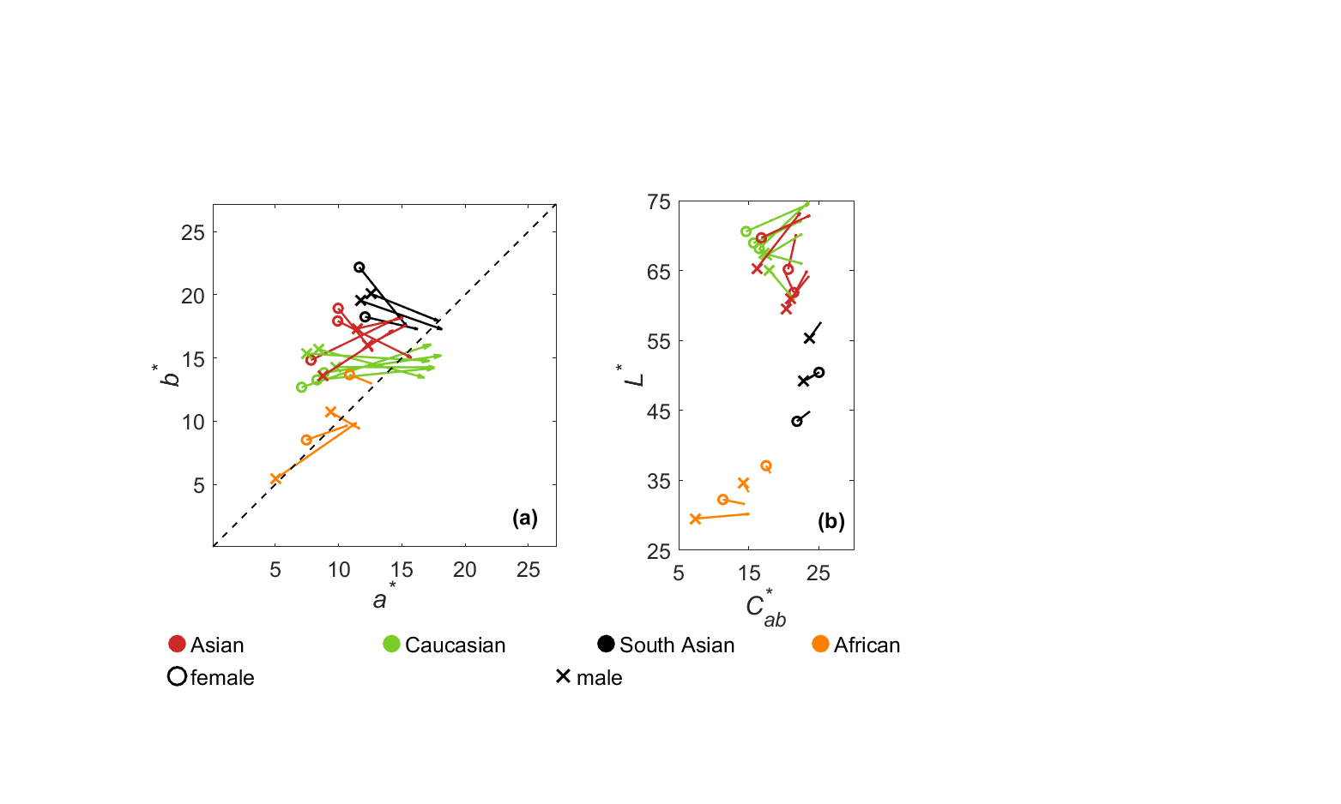
Figure 10. The color shift between the measured and preferred skin colors on (a) a*b* and (b) L*C_{ab}* plane.

It can be seen in Figure 10(a), all the preferred colors appear to be more reddish and have higher chroma than those really measured. As shown Figure 10(b), the chroma increments of preferred skin colors compared with original ones for models with lighter skin colors are larger for the Asian and Caucasian groups, while for Africans, the darker skin colors has larger increments in chroma. The South Asian models generally show an increase in chroma from the original skin colors to the preferred ones, but this increase is much less significant than that observed for the other ethnic groups.

4.2 The Influence of Model Ethnicities on Skin Color Preference

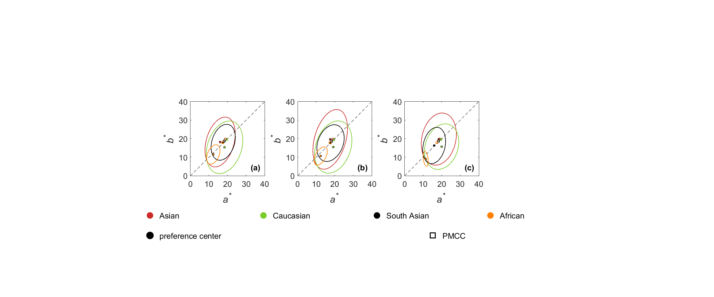
Figure 11. Plots of the preferred skin color ellipses of the 4 ethnicities (colored circles) at (a) high illuminance. (b) medium illuminance. (c) low illuminance, under 6500K of the in-lab condition. The 4 skin colors in the PMC chart are plotted in square.
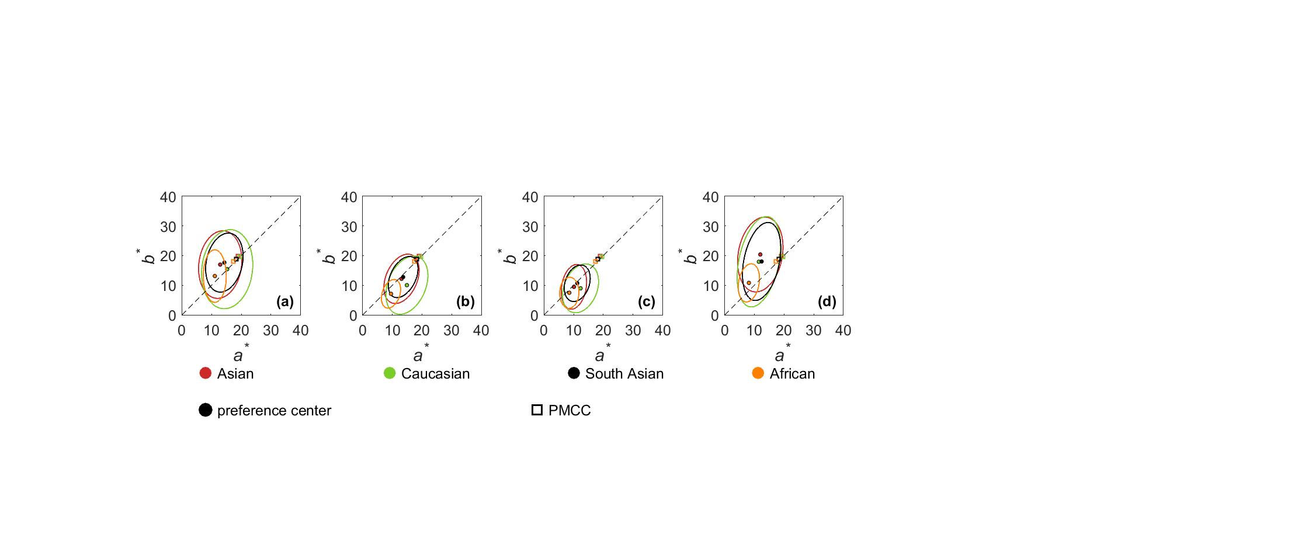
Figure 12. Plots of preferred skin color ellipses of the 4 model ethnicities in the scene types of (a) indoor, (b) outdoor, (c) sunset, (d) night. The 4 skin colors in the PMC chart are also plotted in square.
From Figure 11, it can be summarized that the ellipses for the Asian, Caucasian, and South Asian groups are similar in both center and size, while the ellipse for the African group differs, being much smaller in size and lower chroma for color center.
The preference centers for the Caucasian and Asian groups exhibit the smallest and largest hue angles, respectively, indicating that Asian observers prefer more reddish skin tones for Caucasian models and more yellowish skin tones for Asian models.
The chroma values for the Asian, Caucasian, and South Asian groups are generally similar, while the African group has relatively lower chroma, due to its lower skin lightness. The PMC skin colors give good agreement for all ethnicities except that of African.
Figure 12 shows that the chroma values for all skin tones are higher in indoor and night scenes, than those in outdoor and sunset scenes.

4.3 The Influence of Impression Scales on Skin Color Preference
Figure 13 shows the color centers for different impression scales across four different model ethnicities.
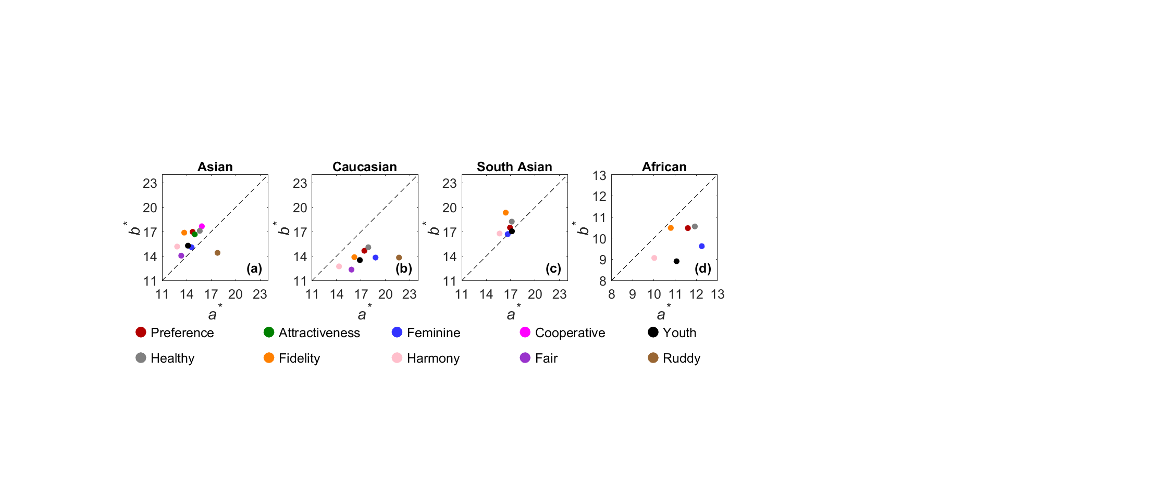
Figure 13. Plots of the skin color centers of different impressions for the (a) Asian, (b) Caucasian, (c) South Asian and (d) African. The results are from the high illuminance level of 6500K light source under in-lab condition.
Figure 13 shows the following trends:
- Despite some variation between impressions, certain trends can be observed within each ethnic group: Ruddy consistently appears the most reddish (lowest hue angle) (see Figure 13 (a), (b)).
- Fair tends to be the least colorful (see Figure 13 (a), (b)).
- The impressions can also be grouped into two categories based on their similar coordinates: Preference and Attractiveness, and Cooperative and Healthy. This agrees with Liu et al.’s finding [18].
- Feminine and Youthful tend to appear more reddish (having lower hue angles) compared to those of the other impressions. The Asian and South Asian groups show similar coordinates between these two scales, while for the Caucasian and African groups, the two scales have similar hue angle, though Feminine is more colorful than Youthful. This also confirmed Liu et al.’s finding [16].
- Fidelity (7) and Harmony (8) have the highest hue angles, with Harmony being less colorful than Fidelity.

Some impression scales haven’t appear in Figure 13 (b), (c) and (d), because after identifying similarities between some pairs of impressions in the Asian group experiment, the redundant ones were removed when studying the other ethnic groups.

4.4 The Influence of Scenes on Skin Color Preference
The present results are first time to show how preferred skin colors differ under 35 scenes.
Figure 14 plots the preference centers of 14 different real scenes for each ethnicity studied. The preference centers of different scene types are plotted with three colors. Specifically, the red, blue and green points represent indoor, outdoor, and night scenes respectively. The vectors are plotted to show the trend of color shift for the indoor and outdoor scene types.

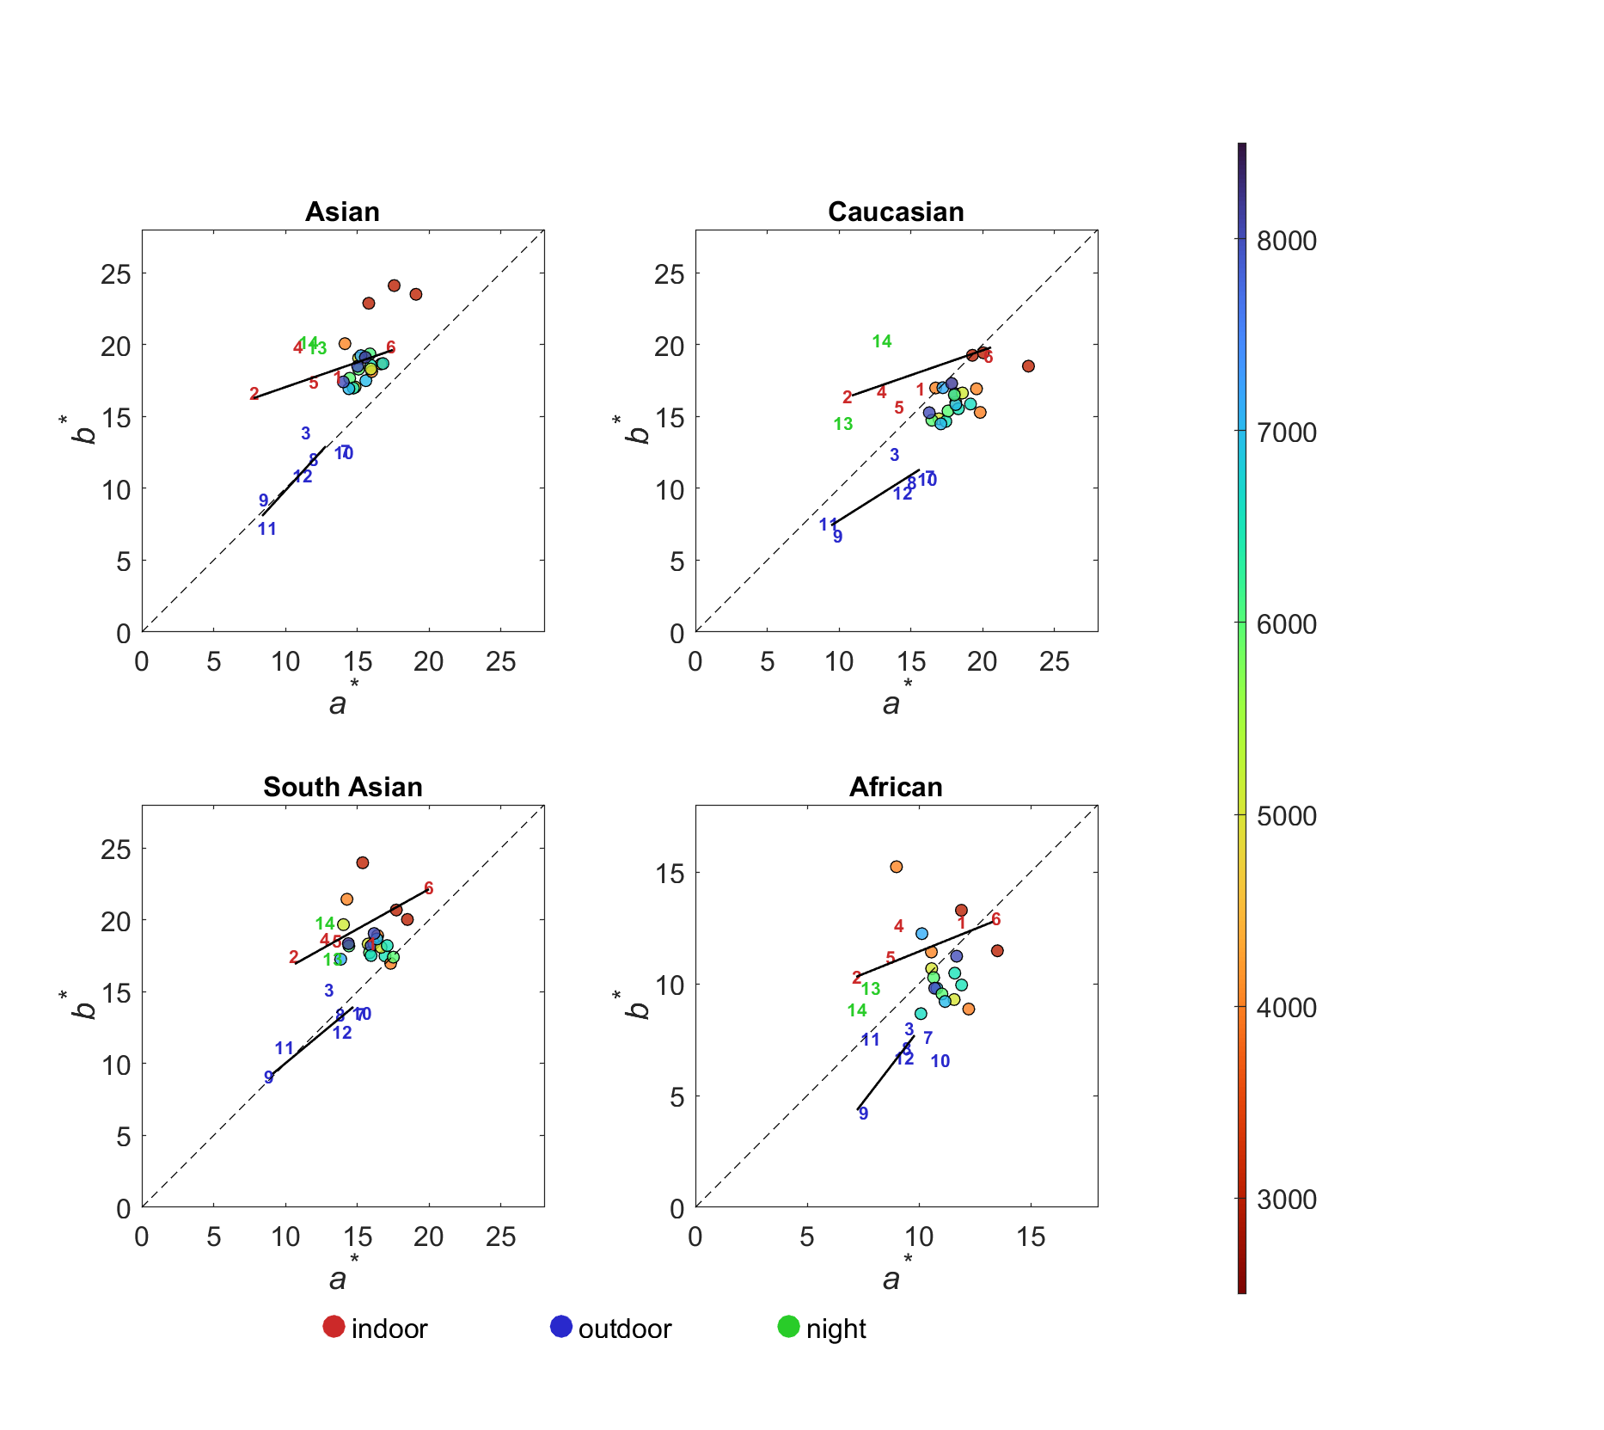
Figure 14. Plots of preferred skin color centers of the 35 scenes (21 in-lab and 14 real scenes) for the four ethnic groups. The colored circles represent the 21 in-lab conditions. The colored digits are for the real scene conditions (with indoor, outdoor and night scene points drawn in red, blue and green colors respectively). 1: Basement 1 mall, 2: Basement 1 store, 3: Sunken plaza, 4: School cafeteria, 5: School canteen, 6: School Starbuck, 7: Grassland with front lighting, 8: Grassland with side lighting, 9: Grassland with back lighting, 10: Overcast scene, 11: Grassland with back lighting at sunset, 12: Grassland with side lighting at sunset, 13: Night scene, 14: Extreme night scene.
Figure 14 plots the preferred skin colors of all the 35 scenes studied. The 5 red label markers located along the upper black trend line represent the preferred skin colors from indoor scenes. The line indicates a clear trend that when CCT decreases, preferred skin colors tend to have higher chroma values and smaller hue angles.
On the other hand, the green label markers along the lower black line showing the outdoor trend (all the scenes have a mean of 6000K ranged from 5000K to 9000K). The hue angles remain relatively stable with an exception of scene 3, of which the hue angle is smaller than the other scenes, possibly due to the fact that the sinking plaza is surrounded by many big buildings, which are often neutral or warm in color, whereas the other outdoor scenes mostly contain blue skies and green vegetation as backgrounds, which introduce a strong simultaneous contrast effect, biasing observers toward skin colors with a smaller hue angle. In the trend line, the chroma varies according on the lighting direction. Specifically, the front-lit scene (scene 7) has the highest chroma, followed by the side-lit scenes (scenes 8 and 12) and then the back-lit scenes (scenes 9 and 11). Note two sunset scenes (11 and 12) also follow the general trend line.
For the two night scenes (13 and 14), the preferred skin colors appear to be much yellower compared with those of the other scenes.

For the 21 in-lab conditions, they are presented in the filled circles according to the CCT slide on the right side. It can be seen almost all the circles are converged in a small region, around (17, 17) of a*b*, except those of low CCT, e.g. 3000K. In addition, the converge region is around (10, 12) for the African ethnicity due to its low chroma comparing with those of the other ethnicities.

Overall, the present results reveal the scattering patterns of preferred skin colors across four types of scene conditions, in-lab, indoor, outdoor and night, respectively.

4.5 The Influence of Model Familiarity on Skin Color Impressions
This effect of familiarity between the model and the observer is also investigated and the results are given in Figure 15. It can be seen that the preference centers for four different model ethnicities, as perceived by both stranger observers and acquaintance observers, across ten distinct impressions. It also includes the average skin tone center of the original images for each ethnic group.
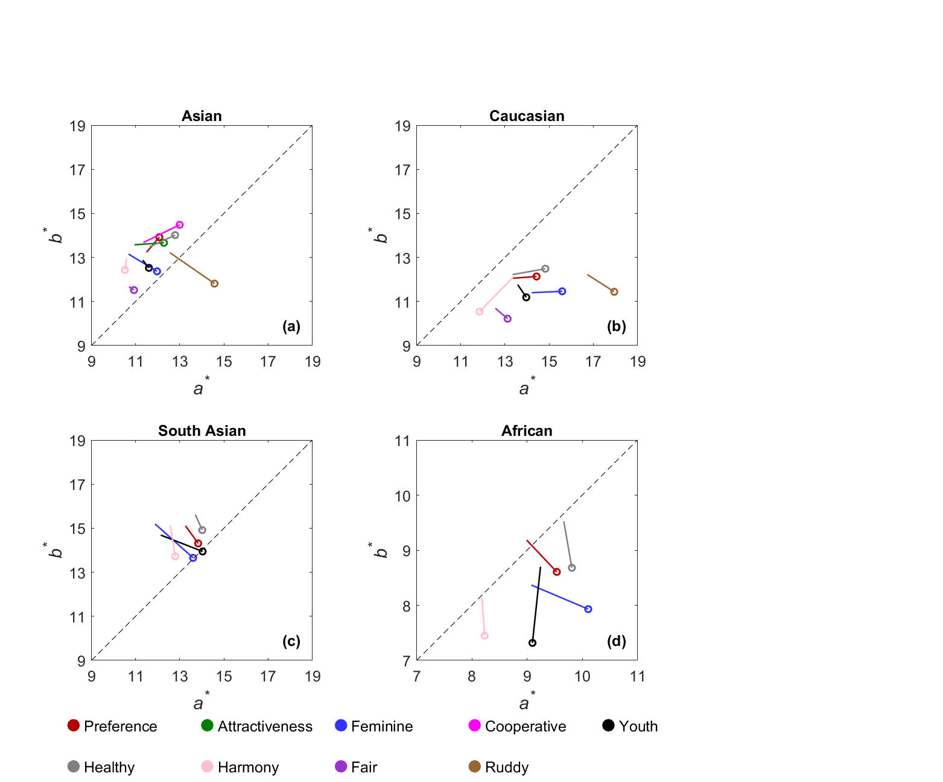
Figure 15 Plot of skin centers for each impression of the four model ethnicities. The data of stranger and acquaintance groups are plotted in circle and open-end signs respectively.
Figure 15 shows that the hue angles of the preference centers for the acquaintance group are larger than those for the stranger group for each impression, i.e. appearing consistently more reddish. Table 5 lists an average hue angle of the in-lab and real scene conditions of each ethnic groups. It can be seen that, there is a difference in hue angle of approximately 2° between the two observer groups, with stranger observers to have a slight preference for redder skin tones. Comparing two groups, the preference centers are generally more yellowish in real-scene conditions than those in in-lab conditions, differing by a hue angle of about 6°.

Table 5. List of the average CIELAB hue angles for preference impression between the stranger and acquaintance groups under in-lab and real scene conditions.

in‐lab | Asian | Caucasian | South Asian | African | mean
strangers | 47 | 38 | 47 | 41 | 44
acquaintance | 49 | 40 | 50 | 42 | 46
real scene | Asian | Caucasian | South Asian | African | mean
strangers | 53 | 45 | 51 | 45 | 50
acquaintance | 55 | 47 | 55 | 47 | 52

4.6 The Influence of Lightness Levels on Skin Color Preference
This section investigates the lightness changes or skin preference. The lightness here reflects the illumination level the image taken. The lightness here is calculated against the display white. Figure 16 shows all models’ preferred skin colors are plotted in a*b* plane, the top and bottom rows for indoor and outdoor scenes respectively. The colors plotted are according to the kin scales on the right.
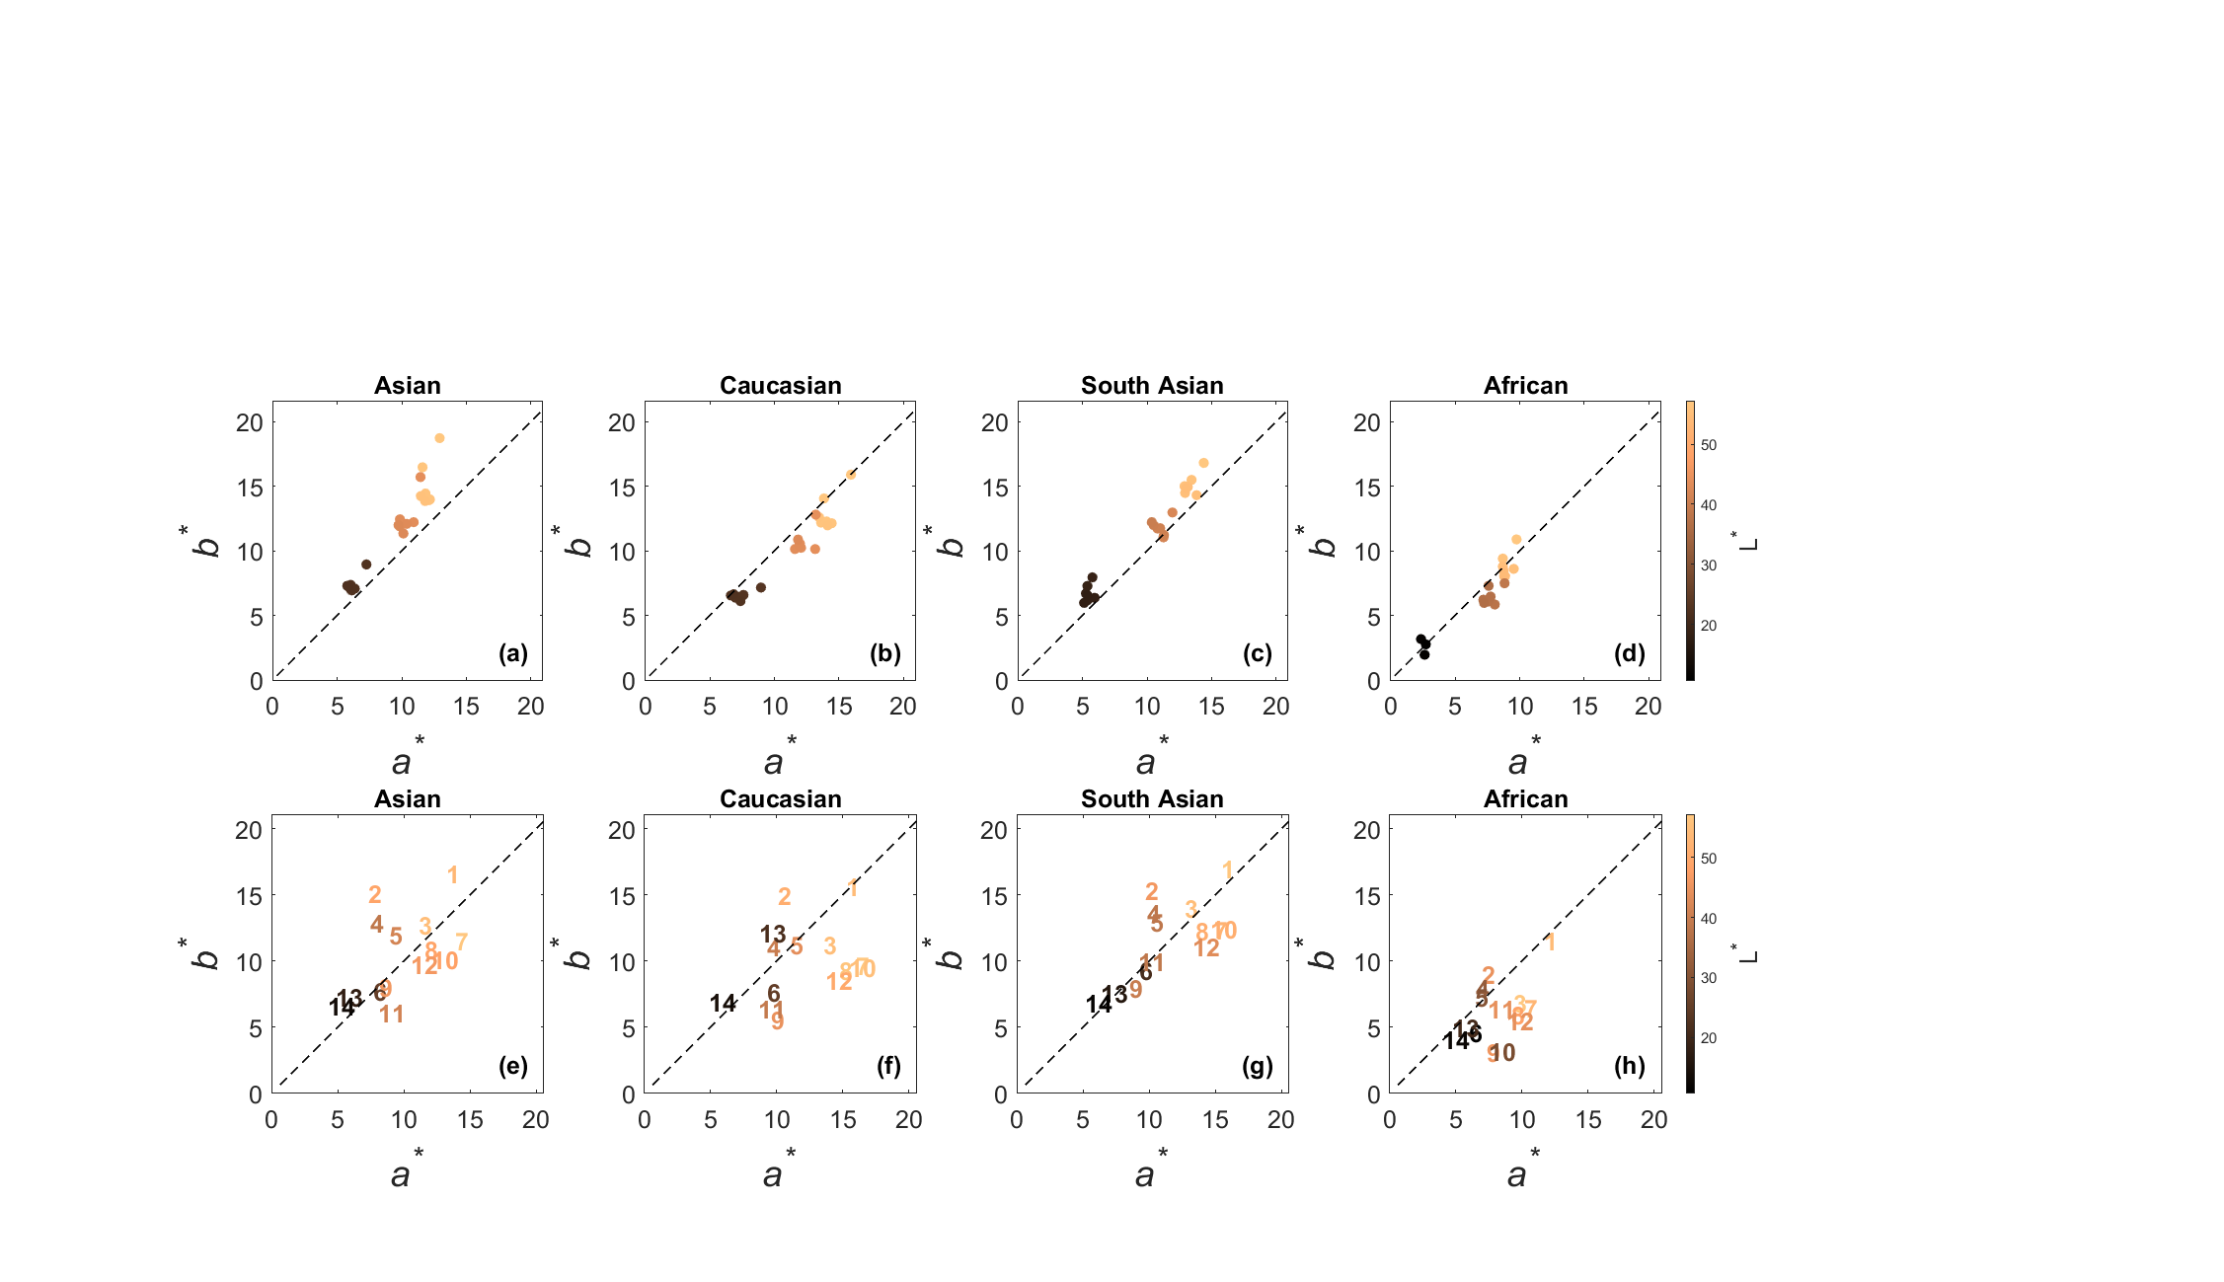
Figure 16. Plot of the preferred skin centers of different L∗ value in a*b* plane for the in-lab and real scene in the top and bottom rows respectively. Each point is plotted according to the lightness scale given aside. For the label marker of each scene, please refer to the caption in Figure 4.
The results from the top row of Figure 16 for both indoor and outdoor scenes show that when comparing the results across three distinct luminance levels (high, medium, and low) under in-lab conditions, a clear trend emerges: chroma increases with luminance levels. This is known as Hunt effect [35]. For the real scene results (bottom row of Figure 16), the results are more scattered than those in top row. However, the pattern is the same, i.e. the brighter images to have a higher chroma.

4.7 Comparison with the previous experiments
The final analysis is to compare the preferred skin colors obtained from many earlier studies. Figure 17 plots the current experiment for four different ethnicities from 8 studies together with the 50% acceptable ellipses from the present study. The 8 studies are Yano [5], Yamamoto et al. [6], Park et al. [10], Deng et al. [9], Zeng et al. [31], Peng et al. [12], Cao et al. [13], and the PMC chart [14].
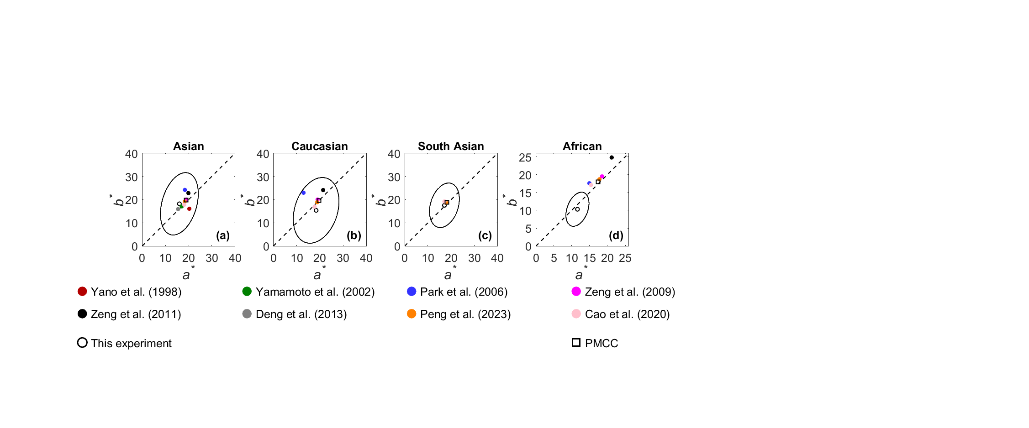
Figure 17 comparison of the preferred skin centers of a) Asian, b) Caucasian, South Asian and d) African ethnicities between the current experiment and those of the previous studies

The results are summarized below:
- In general, all the results agreed well, i.e. they are all within the 50% acceptance ellipses except the present African color.
- The results from Japanese studies [5,6,9] showed the reddish hues, they believe that to make it brighter [19].
- Park results [10] shows the more yellowish hues.
- Luo group’s studies [11,12,15] had hue angles between 45-48º hue angles, except that the present African skin color to be much lower chroma than the other studies. (see Figure 17(d)).
- PMC chart skin colors [14] give reasonable agreement with the experimental results.

- Discussion and Significance

Unique Dataset
The dataset is unique in a way to accumulate a comprehensive dataset. It can be divided into two parts: part 1: experimental images (including 20 models × 35 scene conditions × 33 renditions) and part 2: visual results (including 6-10 impressions by 20 Chinese observers. The 20 models included cover a full range of lightness scale with equal number of genders. Their subgroups travel together to take images in 35 scenes, divided in to 3 types, 21 n-lab conditions, and 5 indoor and 9 outdoor real scenes. In total, 3.5 million assessments were made). Part 1 image data can be reused to assess impressions from observers from other ethnicity groups. Part 2 visual results of different impressions can be used to derive impression models.

Comparing between the measured and preferred skin colors
The present results plotting data in a*b* and L*C_{ab}* planes (Figures 1 and 10) is a good way to show the coverage of the lightness levels of models, to compare male and female skin colors, and to reveal the trend of color shift between the measured and preferred skin colors. For the latter, the present results agreed well with earlier finding from Chinese and Japanese observers [18], i.e. Chinese observers preferred skin colors to be reddish hue for all ethnicities, more vivid (brighter and more colorful) for the Caucasian and Asian ethnicities.

Preferred skin colors between 6-10 impressions
It can be found the trends of impression skin colors are quite consistent between all 4 ethnicities. They can be divided into three groups, (a) Preference and attractive, (b) Healthy and cooperative, (c) Young and feminine are in the same group. Each group has very similar skin centers. These results are similar to those found by Liu et al. [18] and Wang et al. [17].

Preferred skin colors under 35 scenes
The preferred skin colors were analyzed under all 35 scenes. Three distinct trends of color shifts were identified. The first is for outdoor scenes, all the color centers having more or less same redder hue angle than the other scenes. They varied according to the light illuminating to the face, i.e., from front-lit, side-lit to back-lit scenes. The second trend is for the indoor scenes vary largely from reddish higher chroma to yellowish lower chroma colors from 3000K to 6000K respectively, while the preferred colors are less colorful in high CCT. The last trend is that regarding the 21 studio lightings, the results are converged to a small cluster from CCTs of 4000 to 8000K regions except for few 3000K CCT and low illuminance level.

Preferred colors between stranger and acquaintance observer groups
The present results also revealed a difference between the stranger and acquaintance observer groups. This is in accordance with our hypothesis that the familiarity between the model and the observers can influence the relationship between facial impressions and skin colors. The former’s preferred skin colors are consistently redder than those of the latter. Which means, the strangers’ preferred skin color is more close to the original skin colors of the models, as Figure 10 have shown that the original skin colors of the models are more yellowish than the preferred ones. This mechanism beneath this phenomenon might be that according to the studies of Hasantash [36], when the brain’s prior expectation of skin color is violated, under efficient coding and Bayesian decision-making, the visual system amplifies the prediction error in reverse, generating the counterintuitive percept.

- Conclusion
A comprehensive skin color impression database was accumulated, including about 3.5 million assessments. The data includes two parts: 1) experimental images (20 models × 35 scene conditions × 33 renditions) and 2. Visual results: 6-10 impressions by 20 Chinese observers. The 20 models to cover a full range of lightness scale with equal number of genders. Their subgroups travel together to go through 35 scenes, divided in to 3 types, 21 in-lab conditions , and 5 indoor and 9 outdoor real scenes. The results were used to establish ellipse model, which defines the color center and 50% acceptable range.
The 4 goals of the present study have been successfully achieved, and they have been discussed in the last section. The present work can consider a preliminary work. Many works are well worthwhile to do for the future.
- Same experiment can be conducted by using other ethnicity groups or different professionals, such as cosmeticians, photographers.
- Further analysis can be performed on the other impressions rather than heavily focused on preference.
- Models can be developed to predict many impression skin color center, to evaluate the skin quality based on conventional or neural network methods. It can also be used to estimate the quality of preferred skin colors. The data should be modelled to develop the quality of each impression.
- The present data largely disagree with the earlier studies on African preferred skin color. We should intensive study the African skin preferred colors to understand the causes of the huge discrepancy between the present and the other studies.
- The data can be used to develop the preferred skin chart as a calibration target for camera.

Funding
Independent research
Disclosures
The authors declare no conflicts of interest.

References

[1]. C. J. Bartleson: On the Preferred Reproduction of Flesh, Blue-Sky, and Green-Grass. Photographic Science and Engineering 6,19–25 (1961)
[2]. L. Sanders C: Color Preferences for Natural Objects. Illum. Engng. 54,452–456 (1959)
[3]. R. W. G. Hunt, I. T. Pitt, L. M. Winter: The Preferred Reproduction of Blue Sky, Green Grass and Caucasian Skin in Colour Photography. The Journal of Photographic Science 22,144–150 (1974) 10.1080/00223638.1974.11737768.
[4]. D. Sanger, T. Asada, H. Haneishi, Y. Miyake:Facial Pattern Detection and Its Preferred Color Reproduction. on Proceedings,149–153 (1994) 10.2352/CIC.1994.2.1.art00041
[5]. T. Yano, K. Hashimoto: Preference for Japanese complexion color under illumination. Color Research & Application 22,269–274 (1997) https://doi.org/10.1002/(SICI)1520-6378(199708)22:4<269::AID-COL7>3.0.CO;2-N.
[6]. M. Yamamoto: On the preferred flesh colour in Japan, China and South Korea. The Imaging Science Journal (2003)
[7]. J. Kuang, X. Jiang, S. Quan, A. Chiu:A psychophysical study on the influence factors of color preference in photographic color reproduction. In:Image quality and system performance IIon Proceedings,23–33.SPIE,San Jose, California, USA (2005)
[8]. S. R. Fernandez, M. D. Fairchild:Preferred Color Reproduction of Images with Unknown Colorimetry. on Proceedings,274–279 (2001) 10.2352/CIC.2001.9.1.art00050
[9]. D. Pei, W. Kening, N. Aoki, H. Kobayashi: Investigation on the Preferred Flesh Color on Male in Japan and China. Journal of The Society of Photographic Science and Technology of Japan 76,70–76 (2013) 10.11454/photogrst.76.70.
[10]. D. S. Park, Y. Kwak, H. Ok, C. Y. Kim: Preferred skin color reproduction on the display. Journal of Electronic Imaging 15,041203 (2006)
[11]. H. Zeng, R. Luo:Preferred Skin Colours of Africans, Caucasians, and Orientals. on Proceedings,211–216 (2011) 10.2352/CIC.2011.19.1.art00043
[12]. R. Peng, M. R. Luo, M. Cao, Y. Zhu, X. Liu, G. Liu:Preferred Skin Reproduction Centres for Different Skin Groups. on Proceedings,109–113 (2020) 10.2352/issn.2169-2629.2020.28.16
[13]. M. Cao, M. R. Luo, G. Liu:Preferred skin tones reproduction of three ethnic groups under different ambient lighting conditions. on Proceedings,94–94 (2020) 10.2352/issn.2169-2629.2020.28.13
[14]. M. R. Luo: The New Preferred Memory Color (PMC) Chart. Color Research & Application 49,564–576 (2024) 10.1002/col.22940.
[15]. M. Cao, M. R. Luo: A study on Memory Colours. Color and Imaging Conference 29,362–362 (2021) 10.2352/issn.2169-2629.2021.29.362.
[16]. X. Liu, R. Peng, M. R. Luo:The impact of skin colours on visual impression paper presented at the AIC2021 proceedingsMilan, Italy, 2021
[17]. M. Wang, M. R. Luo, K. Xiao:The Impact of Skin Colour on Facial Impressions. In:Proceedings of 13th AIC Congress 2017on Proceedings,OS09–05 (2017)
[18]. Y. He, H. Sato, Y. Mizokami: Cross-cultural comparison of the influence of skin-color change on facial impressions. Iperception 15,e20416695241288032 (2024) 10.1177/20416695241288032.
[19]. R. A. Johnston, A. J. Edmonds: Familiar and unfamiliar face recognition: a review. Memory 17,577–596 (2009) 10.1080/09658210902976969.
[20]. R. S. S. Kramer, A. W. Young, A. M. Burton. (Elsevier Science, Netherlands, 2018), vol. 172, pp. 46–58 10.1016/j.cognition.2017.12.005.
[21]. R. Kok, J. Taubert, E. Van der Burg, G. Rhodes, D. Alais: Face familiarity promotes stable identity recognition: exploring face perception using serial dependence. R Soc Open Sci 4,160685 (2017) 10.1098/rsos.160685.
[22]. V. Chauhan, M. Visconti di Oleggio Castello, M. Taylor, M. I. Gobbini: Familiarity Facilitates Detection of Angry Expressions. Brain Sci 13 (2023) 10.3390/brainsci13030509.
[23]. B. Fink, K. Grammer, P. Matts: Visible skin color distribution plays a role in the perception of age, attractiveness, and health in female faces☆. Evolution and Human Behavior 27,433–442 (2006) 10.1016/j.evolhumbehav.2006.08.007.
[24]. J. L. Brebner, O. Krigolson, T. C. Handy, S. Quadflieg, D. J. Turk: The importance of skin color and facial structure in perceiving and remembering others: an electrophysiological study. Brain Res 1388,123–133 (2011) 10.1016/j.brainres.2011.02.090.
[25]. T. B. Fitzpatrick: The validity and practicality of sun-reactive skin types I through VI. Arch Dermatol 124,869–871 (1988) 10.1001/archderm.124.6.869.
[26]. M. Li, M. R. Luo: Two-dimensional Models to Predict a New Colour Appearance Dataset. Color and Imaging Conference 32,148–148 (2024) 10.2352/CIC.2024.32.1.26.
[27]. . (2004), vol. CIE 015:2004,
[28]. G. Hong, M. R. Luo, P. A. Rhodes: A study of digital camera colorimetric characterization based on polynomial modeling. Color Research & Application 26,76–84 (2001) https://doi.org/10.1002/1520-6378(200102)26:1<76::AID-COL8>3.0.CO;2-3.
[29]. M. R. Luo, G. Cui, B. Rigg: The Development of the CIE 2000 Colour-difference Formula: CIEDE2000. Color Research & Application 26,340–350 (2001) 10.1002/col.1049.
[30]. M.-J. Liaw, C.-Y. Chen, H.-P. Shieh:Color characterization of an LC projection system using multiple-regression matrix and look-up table with interpolation. In:Projection Displays IVon Proceedings,159–168.SPIE,Bellingham, Washington (1998) 10.1117/12.305530
[31]. H. Zeng, M. R. Luo: Skin color modeling of digital photographic images. Journal of Imaging Science and Technology 55,1–12 (2011) 10.2352/J.ImagingSci.Technol.2011.55.3.030201.
[32]. C. Li, Z. Li, Z. Wang, Y. Xu, M. R. Luo, G. Cui, M. Melgosa, M. H. Brill, M. Pointer: Comprehensive Color Solutions: CAM16, CAT16, and CAM16-UCS. Color Research & Application 42,703–718 (2017) 10.1002/col.22131.
[33]. M. Wang, PhD thesis, University of Leeds, Leeds, UK (2017)
[34]. P. A. García, R. Huertas, M. Melgosa, G. Cui: Measurement of the relationship between perceived and computed color differences. J Opt Soc Am A Opt Image Sci Vis 24,1823–1829 (2007) 10.1364/josaa.24.001823.
[35]. R. W. Hunt: Light and dark adaptation and the perception of color. J Opt Soc Am 42,190–199 (1952) 10.1364/josa.42.000190.
[36]. M. Hasantash, R. Lafer-Sousa, A. Afraz, B. R. Conway: Paradoxical impact of memory on color appearance of faces. Nature Communications 10,3010 (2019) 10.1038/s41467-019-10073-8.

